RESUME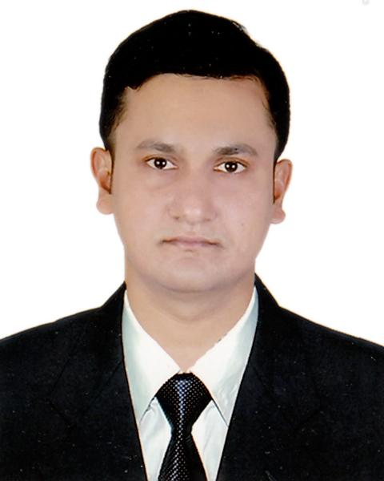

**Md. Nurullah Rafi**

Holding NO #106, Shikkha gram, Alexander, Ramgoti,

Laxmipur-3730

Contact: 01913- 971850

E-mail: nurullahrafi@gmail.com

**Objective:**

I plan to work sincerely and efficiently with an organization, which will utilize my best potentials, accelerate my professional development and build best confidence in me.

**Key Strength:**

I am dedicated, hardworking and willing to put effort to get the job done. I possess exceptional ability to establish instant rapport with people based on outstanding communication skills.

**Academic Qualification:**

* **Master of Business Studies (MBS)**

Result : First class

Institution : Dhaka College, National University

Year of passing : 2013

Subject : Accounting

* **Bachelor of Business Studies (BBS)**

Result : First class

Institution : Noakhali Govt. College, National University

Year of passing : 2012.

Subject : Accounting

* **Higher Secondary Certificate (HSC)**

Result : 3.70 out of 5

Group : Business Studies

Institution : A.S.M Abdur Rab Govt. College

Year of passing : 2008

Board : Comilla.

* **Secondary School Certificate (SSC)**

Result : 3.50 out of 5

Group : Science

Institution : Alexander Pilot High School

Year of passing : 2006.

Board : Comilla.

**Interests**

Conducting programs, Driving, Cycling, Internet surfing, Studying, Traveling, and listening to songs & music.

**Computer Proficiency:**

* Application Software : MS Office & Internet.

**Personal Detail:**

* Name : Md. Nurullah Rafi
* Father’s Name : Md. Ahalulla Shahidi
* Mother’s Name : Nasrin Akhter
* Date of Birth : 1st January,1990
* Religion : Islam
* Nationality : Bangladeshi (by birth)
* Marital Status : Single
* Height : 5’ 6” (Five feet six inches)
* Permanent address : Vill: Shikkhagram, Post: Alexander,

Thana – Ramgoti, Dist: Lakshmipur.

**Language Skills:**

* Bangali : Mother Tongue
* English : Fluent in four skills

**References:**

|  |  |
| --- | --- |
| **Mr. Obydullah Al Marjuk**  Lecturer  Department of Social Science and Humanities  Additional Director  Institutional Quality Assurance Cell(IQAC), and  Associate Director  Center for Social Science Research(CSSR)  Independent University, Bangladesh(IUB)  Cell: 01917-009228  Email: majuk@iub.edu.bd | **Hashan Mahamud**  Senior Lecturer  Department of Statistics  Savar Model college  Savar, Dhaka.  Cell: 01708-338258 |

I hereby, declare that all information stated above is true.



__________________ (Md. Nurullah Rafi)